Designing the Top K Search
Designing the Top K Tags
Designing the Top K Songs
Designing the Top K Tweets
Designing the Top K Instagram Post

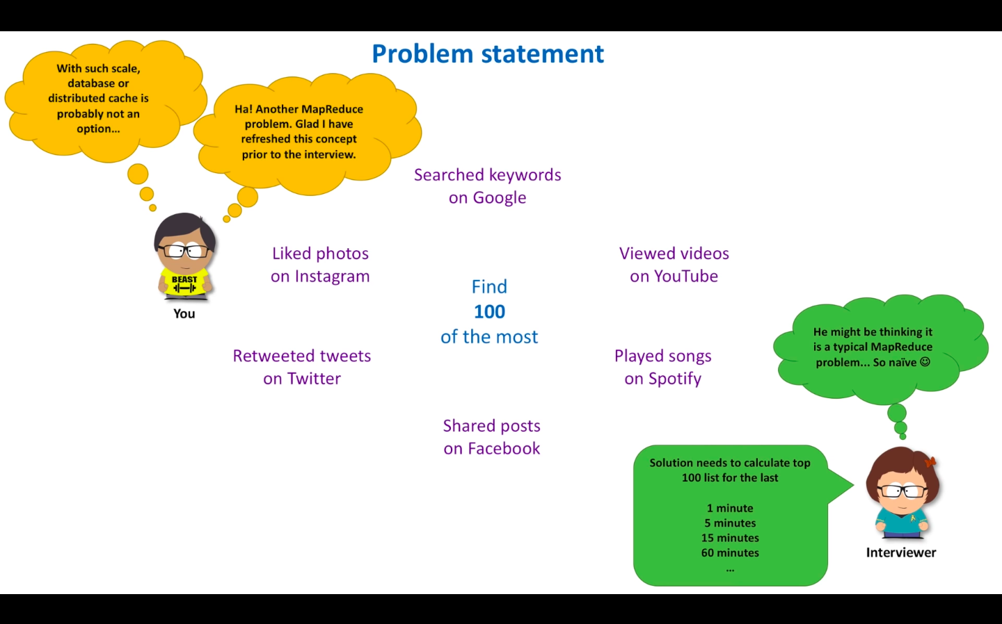

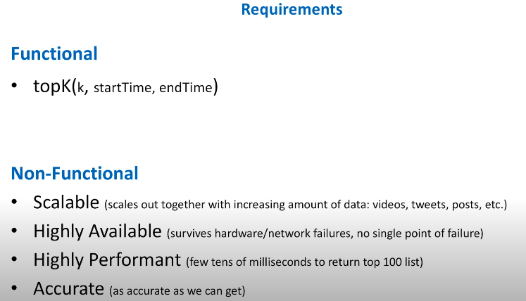

As per the requirement Actor/Client want K result. That mean if we want to return the result in tens of milliseconds, Then we have to pre calculate the results. And for request we can return the result.

Start Discussing :

Solution 1 :. Sampling : We can use sampling, But it will not generate the result Because it generate the result based on the sample we picked. So no need to use this.

Solution 2 :HashTable/HashMap Single Host: If the Size is too big So hash Table will create the Issue because of Very Big size and then we have to perform the sorting based on its frequency count. So it will require O(nlog(n)) time complexity. So we can add Heap along with HashMap/HashTable With heap it will give O(nlog(k)) complexity.

As the solution is simple to implement But This solution will not work with large traffic and also its a single system So if its down complete system will down. So it will be a bottleneck for large traffic of data.

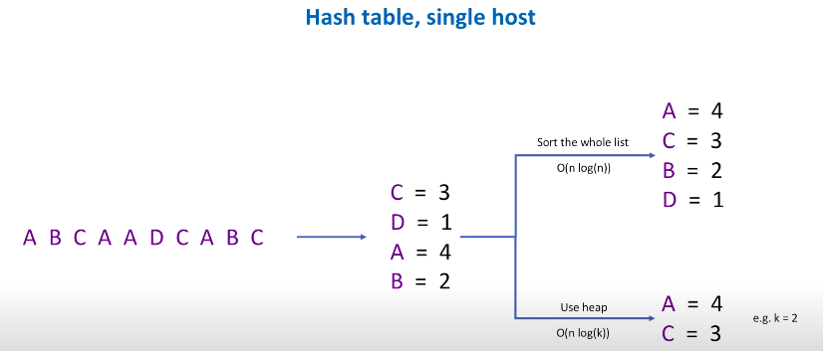

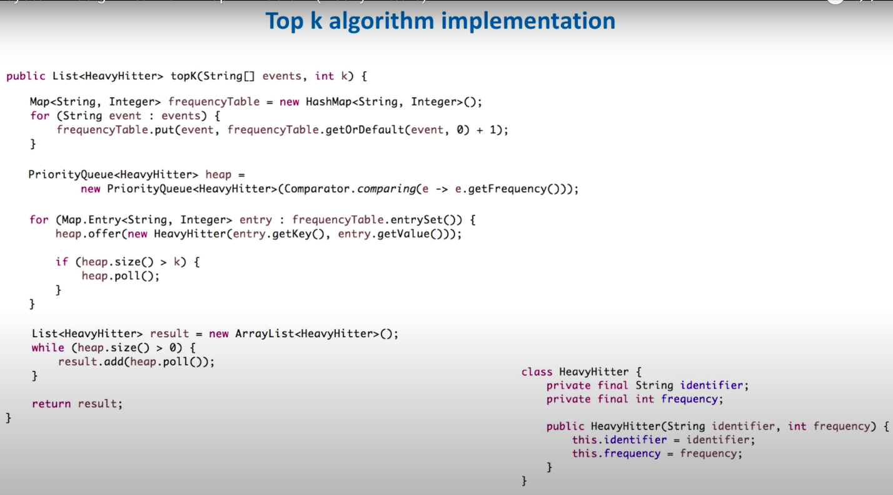

Solution 3 :HashTable/HashMap Multiple Host : We can process event in Parallel. In this solution we are storing the hashTable on each server and divide the load into multiple processor host. So load will be distributed But Still not a good solution as on each server we are storing the hashTable and if size is too big it will create the issue and also the aggregator log will also take time in computing the result. So its also not a good solution.

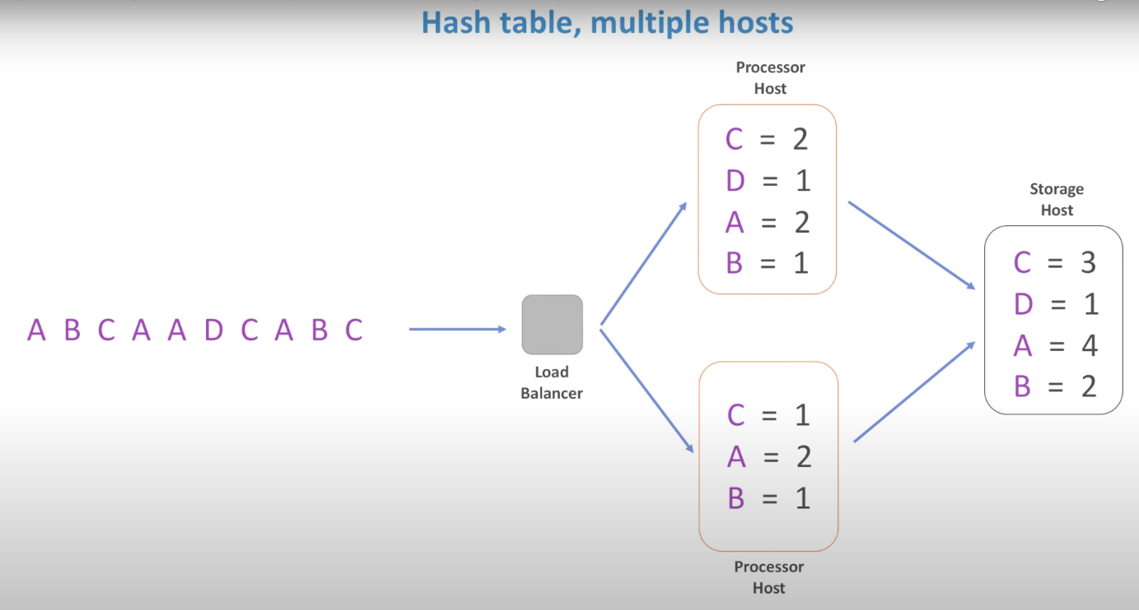

Solution 4 :HashTable/HashMap Multiple Host, Partioning : We can do the partitioning based on some prefix or may be based on first 3 chars. So it will distribute the load across the server So the hashtable size will also decrease. And also we can calculate the top k reasult in each host. And pass this information to Storage host thier we can merge all the k sorted result and can generate the actual K results. As the stream is infinite So This solution is good but it doesn’t give the more accurate result.

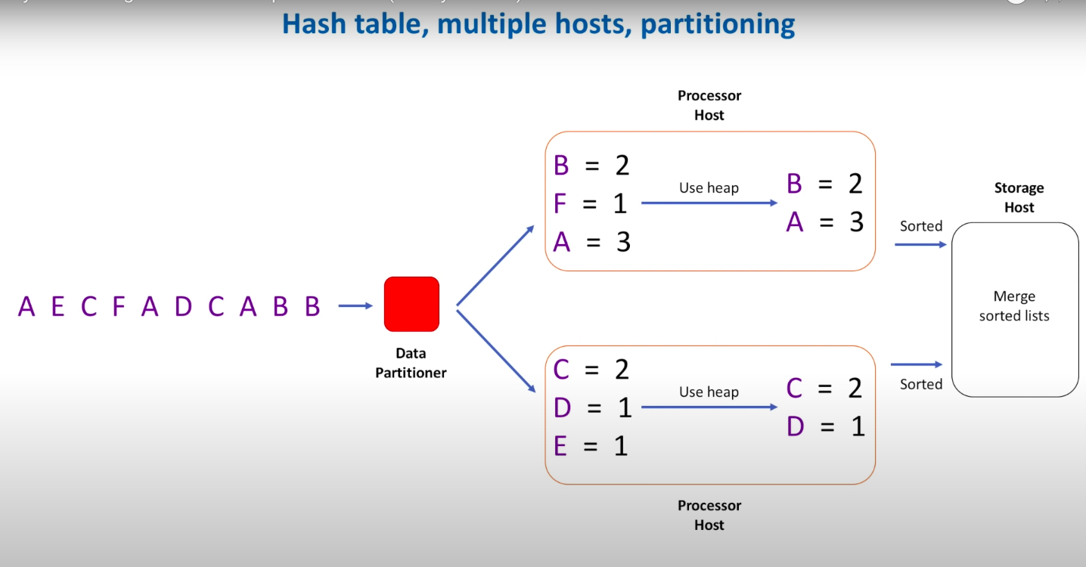

BEST Solution 6 : Max Heap + Use Count Min Sketch :

In this Solution we will not use hashTable/HashMap instead of this we will use the Count Min Sketch

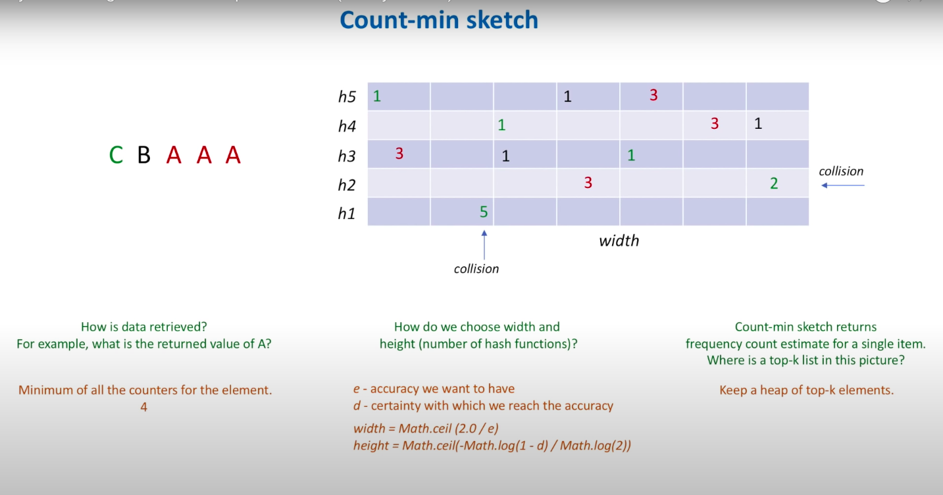

HLD :

Step 1:
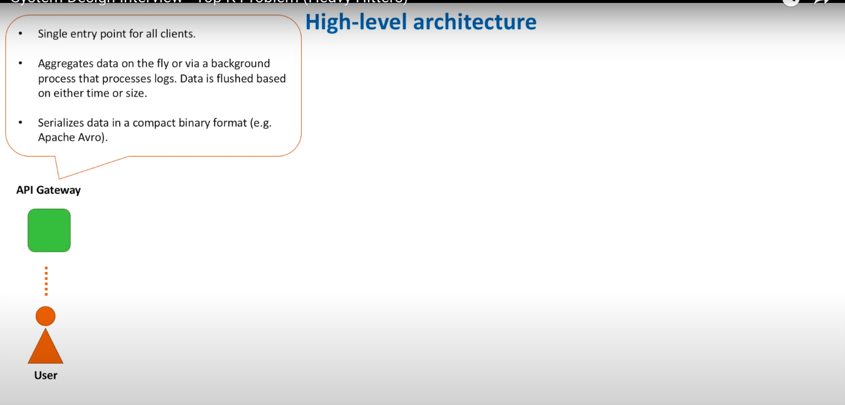
Step 2:

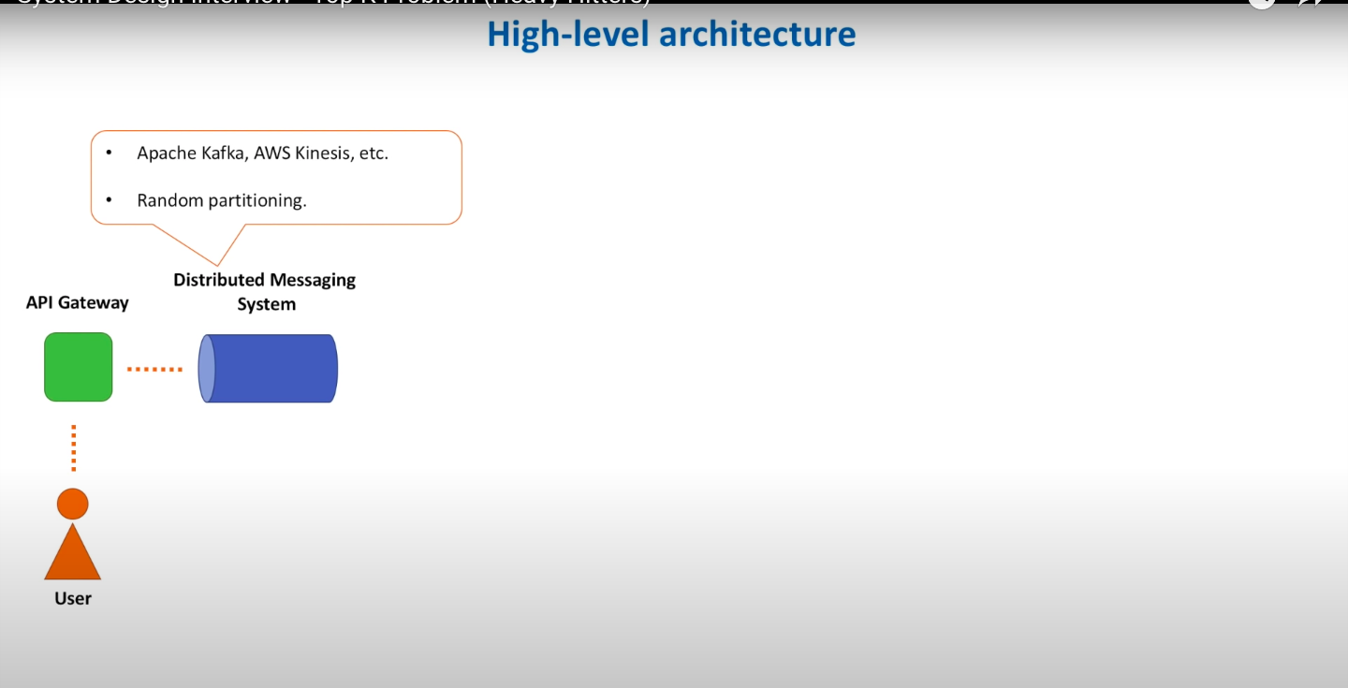

Steps 3:

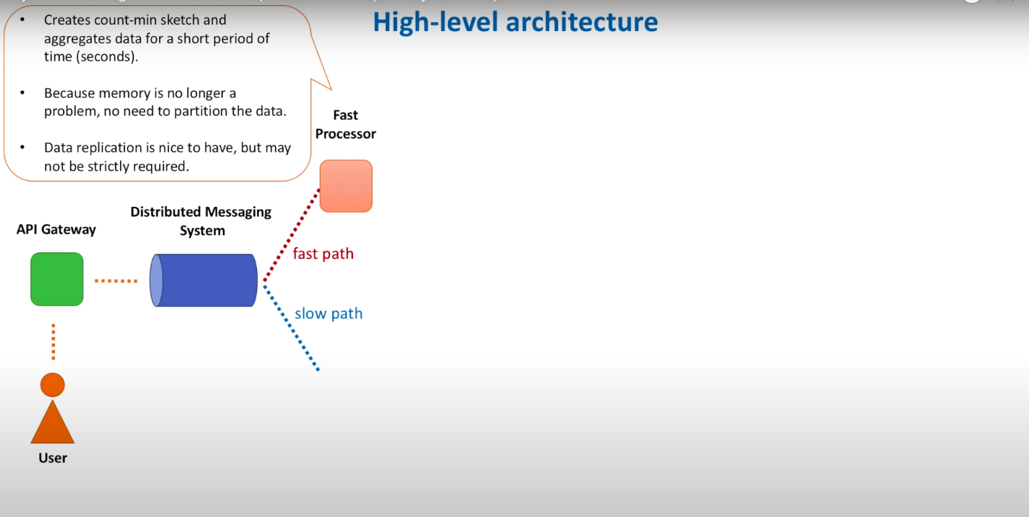

Steps 4 :

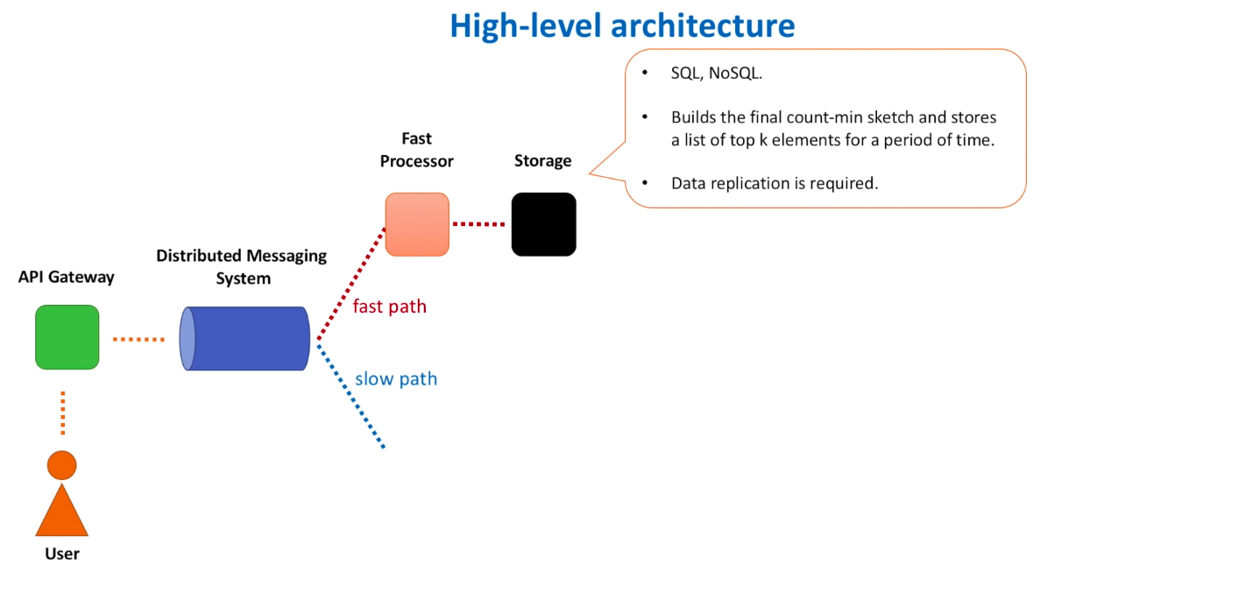
Steps 5 :

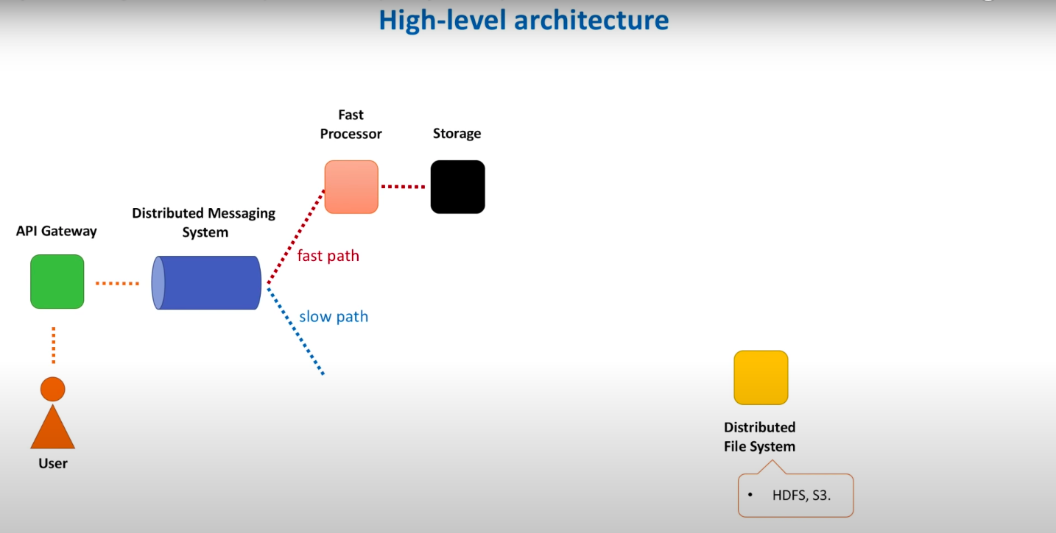
Steps 6 :

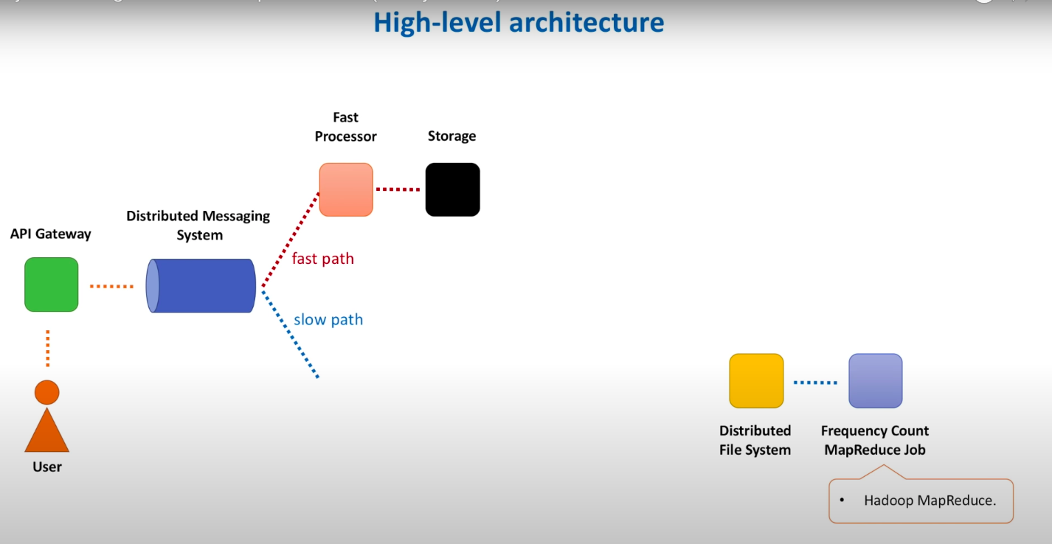
Steps 7 :

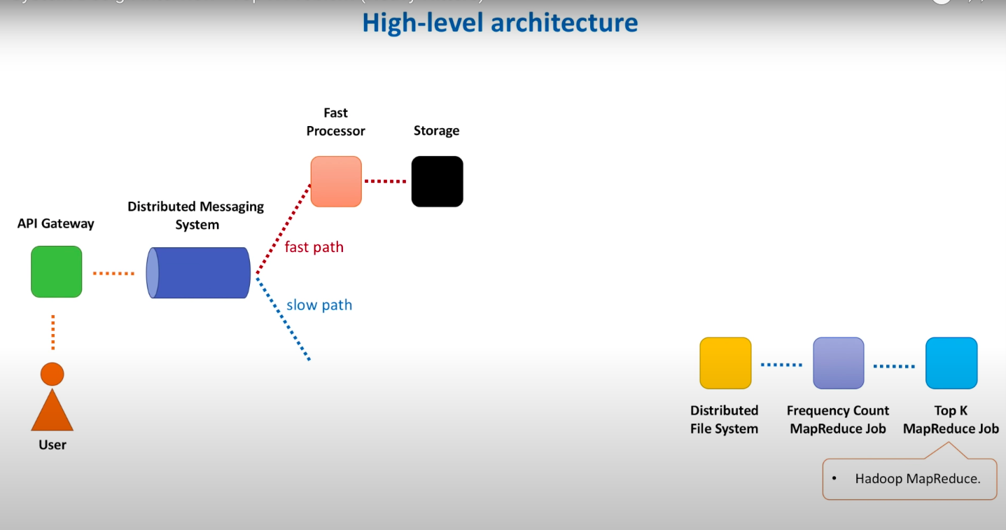

Steps 8 :
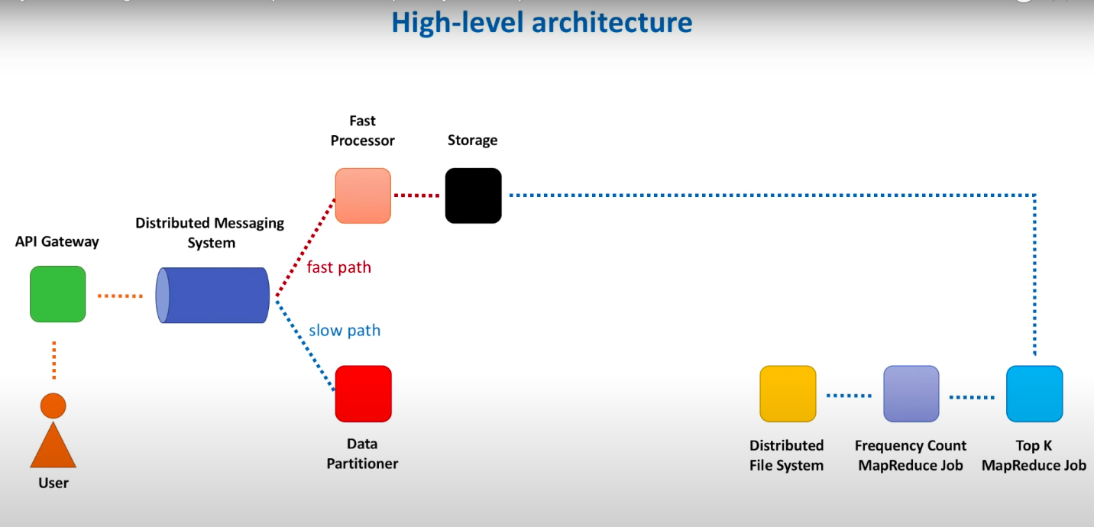

Steps 9 :
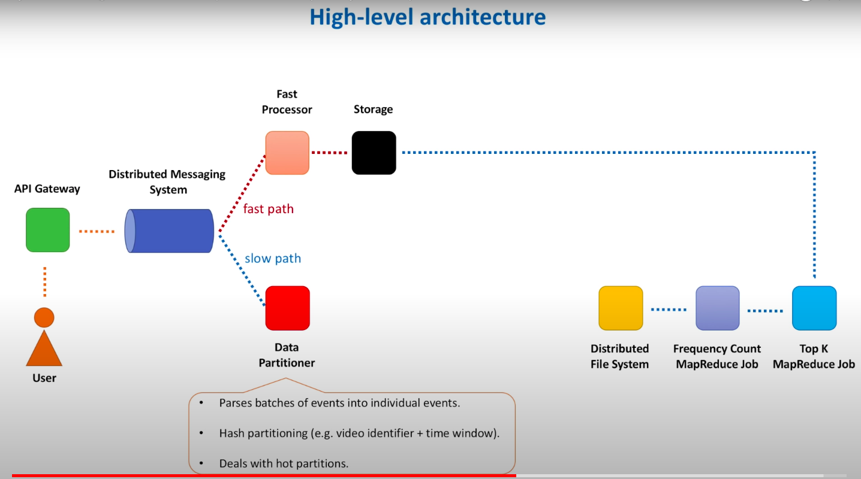
Steps 10 :
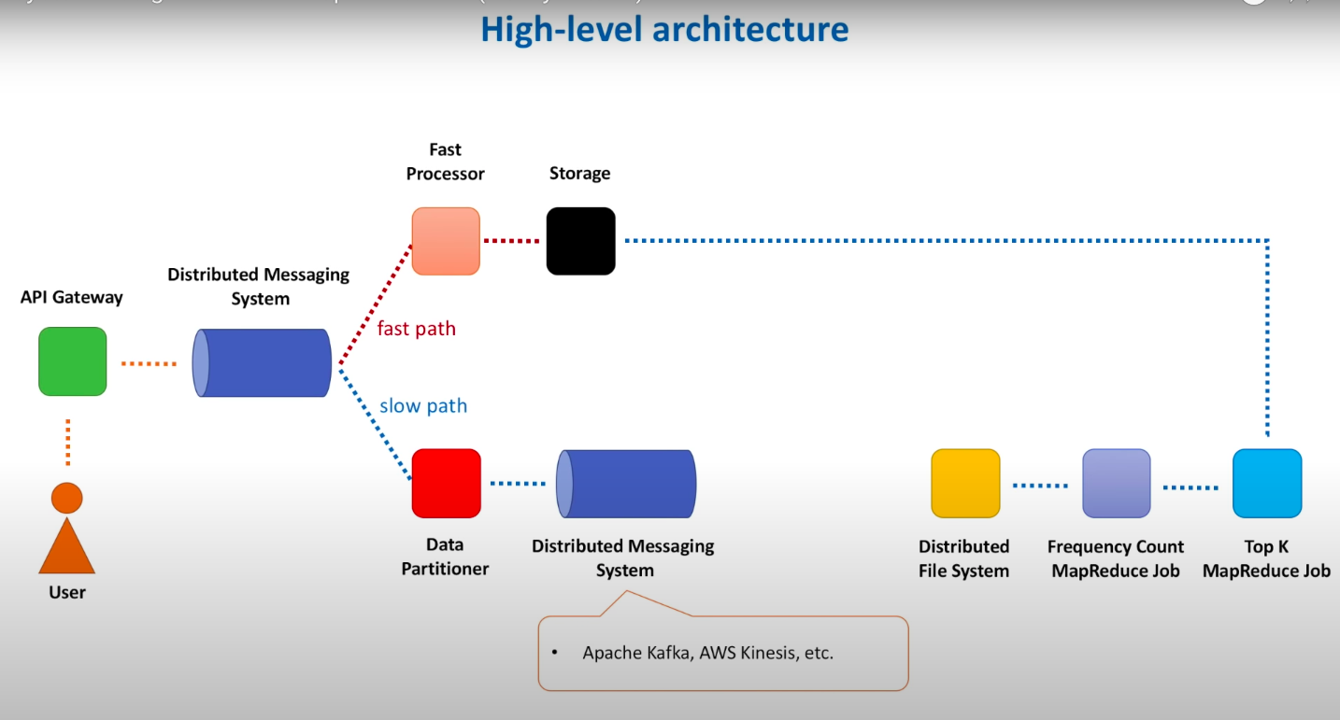
Steps 11:

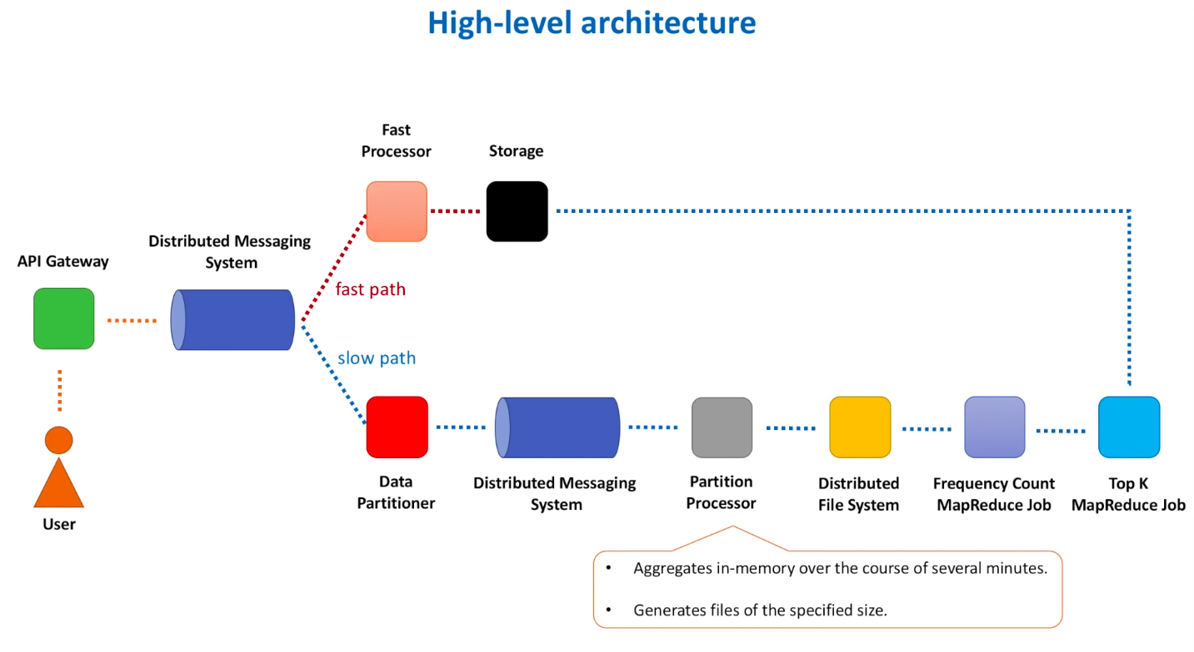

Fast Processor Approach :

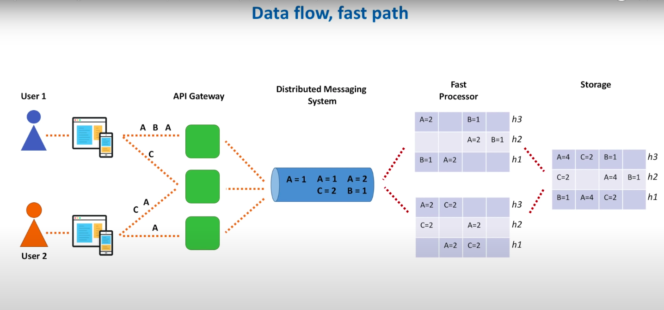

Slow Processor Approach :


Map Reduce Jobs used in Slow Processor

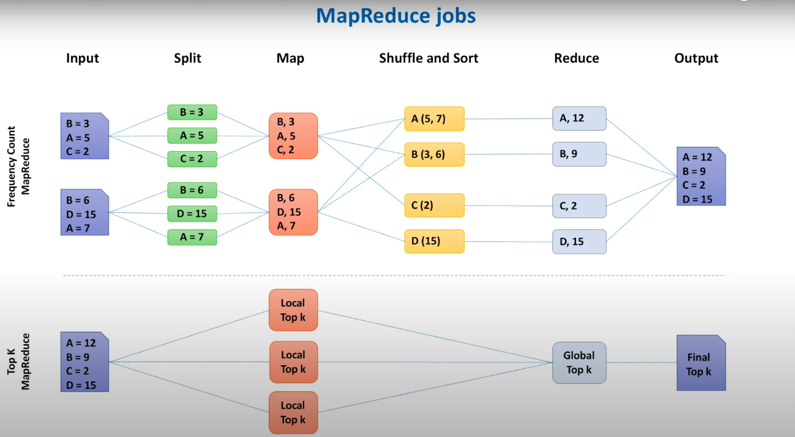

How to retrieve the Data for Top K result :

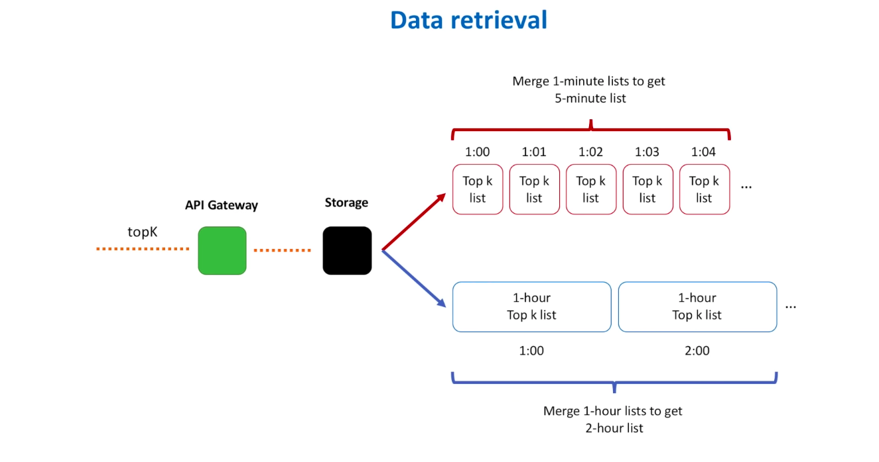

What interviews can ask :

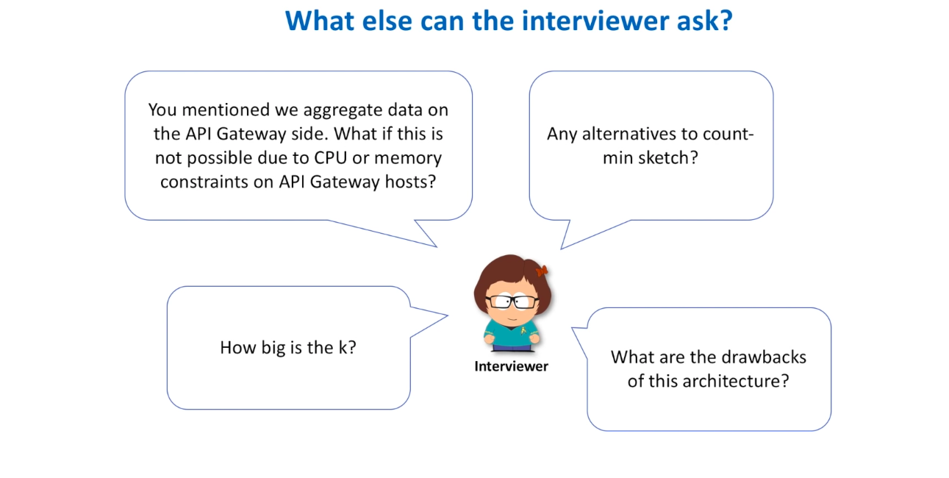

This Solution can also works below System Design as well



